SIMATS ENGINEERING

ASSESSMENT TOOL 2

COURSE NAME: INTERNET PROGRAMMING COURSE CODE: CSA43

COURSE OUTCOME COVERED

CO 5: Construct interoperable web services by leveraging JAX-RPC, WSDL, SOAP, and XML Schema for seamless data exchange across distributed systems.(L4,L5)

Assessment Tool : Alternative Solution Design
Weightage: 20%

QUESTIONS: Total Marks: 25
- A company needs to develop a web service for a mobile and web application. Analyze both REST and SOAP approaches and design an appropriate solution by selecting one. Justify your choice based on performance, scalability, and security requirements.

- An online platform expects a large number of users accessing its services simultaneously. Design a scalable service architecture showing how client, server, API, and database interact. Propose an alternative design to improve scalability and justify your approach.

- A banking application requires secure communication between client and server. Analyze available communication protocols and select the most suitable protocol. Justify your selection based on security, reliability, and performance.

- An application needs to integrate with third-party services such as payment gateways or maps. Design an API integration strategy, including request handling, authentication, and response processing. Suggest an alternative approach to improve efficiency or reliability.
- A web service frequently encounters errors during client requests. Design an error handling and fault tolerance mechanism. Propose alternative strategies to improve system reliability and ensure smooth user experience.

Code of Conduct:

I G. Althaf / 192372004(Name / Reg No) certify that this submission is my original work and that I have adhered to the guidelines specified for this assessment.
I understand that any violation of academic integrity rules will result in disciplinary action.
G.Althaf
Signature of the student:

RUBRICS FOR CALCULATION:

Criteria |  | Weighta ge (%) | Level 4 (Exemplary) | Level 3 (Proficient) | Level 2  (Developing) |  | Level 1  (Beginning)
Problem Understanding |  | 20% | Clearly defines problem, objectives, and all requirements  accurately | Understands problem with minor gaps | Partial understanding; misses key  requirements |  | Misinterpret s or fails to understand  problem
Generation Solutions | of | 25% | Develops multiple innovative and feasible alternatives with clear  differentiation | Generates relevant alternatives with minor limitations | Limited repetitive alternatives | or | Fails to generate meaningful  alternatives
Evaluation Alternatives | of | 25% | Critically compares alternatives using appropriate criteria and  metrics | Compares alternatives with some justification | Basic superficial comparison | or | No proper comparison conducted

Solution Selection | 20% | Selects best solution with strong  justification and  decision rationale | Selects suitable  solution with  moderate justification | Selection is weakly justified | No clear or justified selection
Feasibility | 10% | Applies relevant concepts ensuring high feasibility and practicality | Applies concepts with minor issues | Limited feasibility or incorrect application | Solution is impractical or conceptually  incorrect

REST vs SOAP – Selection and Design

Introduction

For a mobile and web application, both REST and SOAP can provide web services. However, REST is the more suitable choice when the application requires high performance, scalability, simple integration, and efficient communication.

REST vs SOAP Comparison

Feature | REST | SOAP
Architecture | Resource-based | Protocol-based
Data format | Mainly JSON; also XML | XML
Performance | Generally faster and lightweight | More overhead
Scalability | Highly scalable | Scalable but comparatively heavier
Mobile applications | Very suitable | Less convenient
Security | HTTPS, OAuth, JWT, etc. | HTTPS + WS-Security
Communication | HTTP methods | SOAP messages
Complexity | Simple | More complex
Caching | HTTP caching can be used | Less straightforward
Best suited for | Mobile apps, web APIs,  cloud services | Enterprise systems requiring formal contracts  and WS-* features

Selected Approach: REST

I would select REST API for the mobile and web application.

Proposed Architecture
Mobile App / Web App
|
| HTTPS Request

↓
REST API Gateway
|
+ + +
| |
↓ ↓
Application Authentication Server Service
|
↓
Database
|
↓
JSON Response
|
↓
Mobile / Web Client

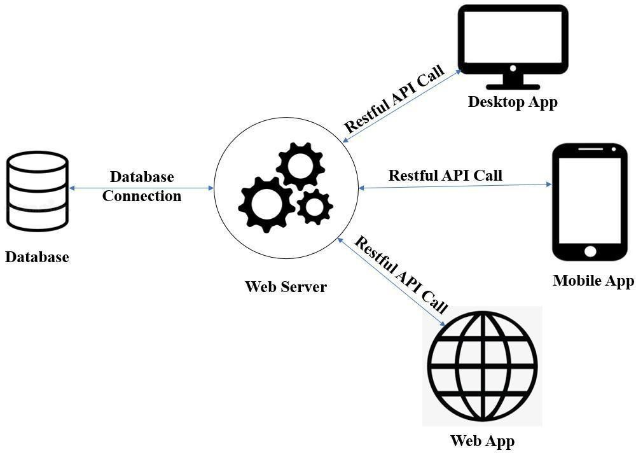

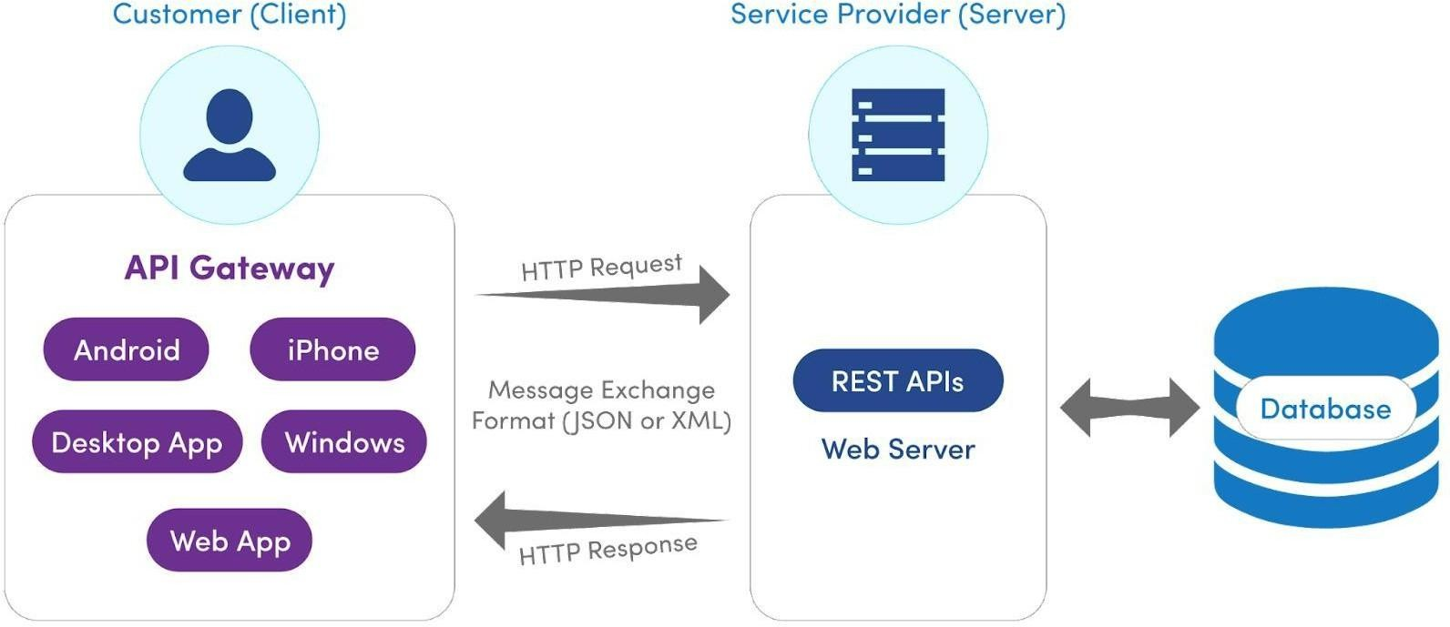
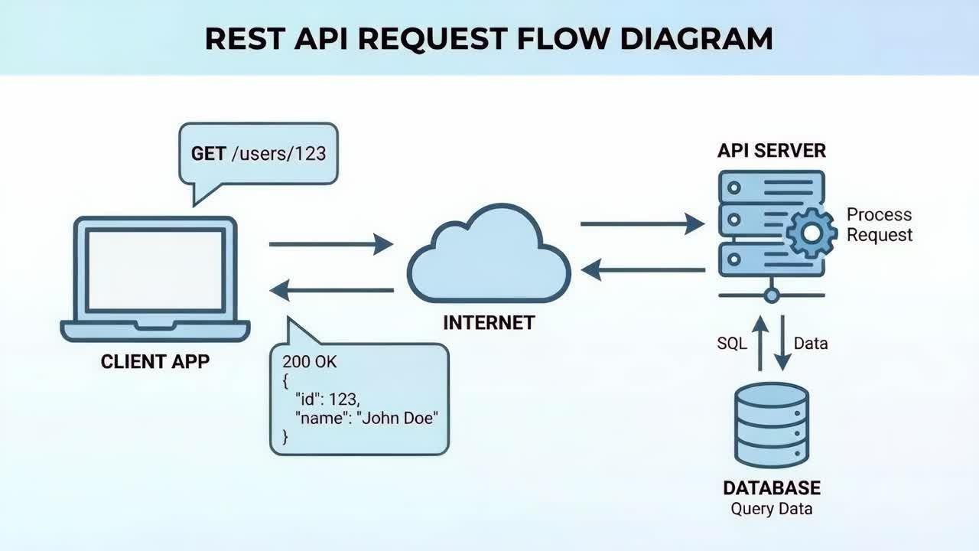

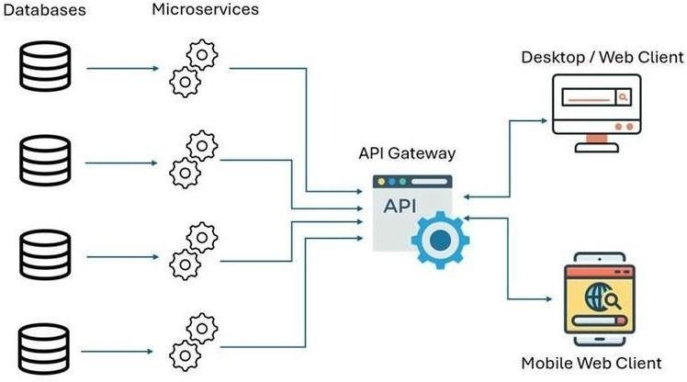

Example REST Request
GET /api/products/101

Example Response

{
"id": 101,
"name": "Laptop", "price": 55000
}

Justification

Performance:
REST commonly uses JSON, which is lightweight and requires less processing and bandwidth than SOAP's XML envelopes.

Scalability:
REST services can be designed as stateless services, allowing requests to be distributed across multiple servers using load balancing.

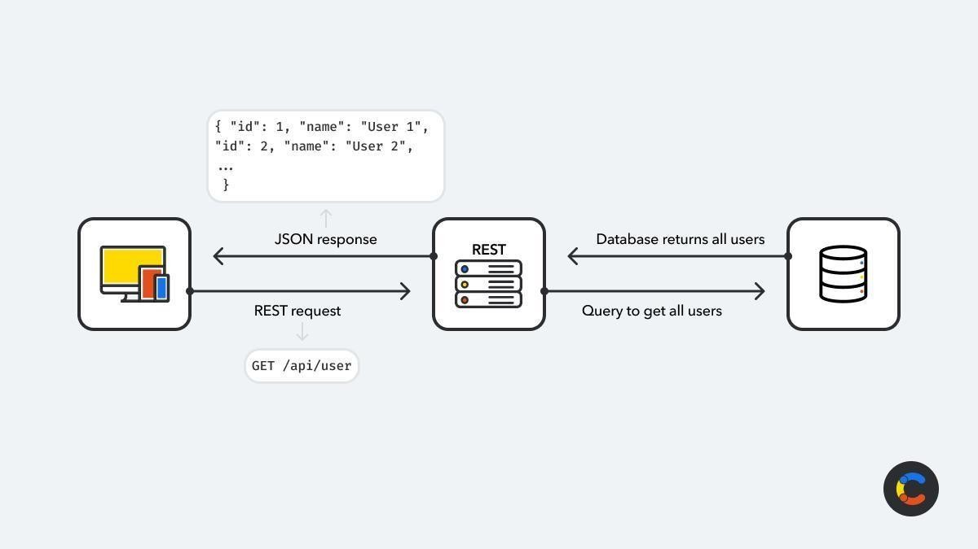

Security:
HTTPS provides encrypted communication, while authentication and authorization can be implemented using mechanisms such as OAuth 2.0 or tokens such as JWT.

Mobile compatibility:
REST APIs are easy to consume from Android, iOS and web applications.

Simplicity:
Standard HTTP methods such as GET, POST, PUT and DELETE make REST APIs relatively simple to develop and consume.

Conclusion

For a mobile and web application, REST is the better general-purpose choice because it provides lightweight communication, good scalability, strong performance and easy client integration. SOAP would be preferable when specialized enterprise features such as WS-Security or formal SOAP-based contracts are essential.

Scalable Service Architecture

Basic Architecture
Multiple Clients
/ | \
Mobile Web Desktop
\ | /
↓
Load Balancer
↓
Application Server
↓
API
↓
Database

Working

Clients send requests to the application.

The load balancer distributes requests among available servers. The API receives and validates requests.
Application servers process business logic.

The database stores and retrieves required information. The response is returned to the client.

Alternative Scalable Design

A better design for very high traffic is a distributed architecture:

Clients
↓
Load Balancer
↓
API Gateway
↓
+ + +

↓ ↓ ↓
Service A Service B Service C
↓ ↓ ↓
+ + +
↓
Cache / Queue
↓
Database Cluster

Advantages

Multiple application servers prevent a single-server bottleneck. Load balancing distributes traffic.
Caching reduces repeated database queries.

Message queues can handle background tasks asynchronously. Database replication can improve availability and read performance. Services can be scaled independently.
Conclusion: For large numbers of simultaneous users, a load-balanced, stateless API architecture with caching and database scaling provides better scalability than a single application server.

Secure Communication for Banking Application

Protocol Comparison

Protocol | Security | Reliability | Performance | Suitability
HTTP | Low without encryption | Good | High | Not suitable for banking
HTTPS | High with TLS | High | Good | Highly suitable
FTP | Not designed for web | Good | Good | Not suitable

Protocol | Security | Reliability | Performance | Suitability
 | transactions
SMTP | Email communication | Good | Moderate | Not suitable
WebSocket + TLS | High | High | Very good | Useful for real-time communication

Selected Protocol: HTTPS

HTTPS (HTTP Secure) should be selected for communication between the banking client and server.

Banking App
|
| HTTPS
| TLS Encryption
↓
Banking Web Server
|
↓
Authentication
|
↓
Banking Database

Justification

Security:
HTTPS uses TLS to encrypt data during transmission and helps protect sensitive information from interception and tampering.

Reliability:
HTTPS provides reliable communication over TCP and supports secure request-response communication.

Performance:
Modern TLS implementations have relatively low overhead, making HTTPS practical for banking applications.

Additional Security:
The application should also use strong authentication, authorization, secure session management, input validation and appropriate transaction controls.

Conclusion

HTTPS with TLS is the most suitable standard protocol for banking client-server communication because it provides confidentiality, integrity and server authentication while maintaining good performance.

API Integration with Third-Party Services

Proposed API Integration Strategy

Suppose an e-commerce application needs to integrate with a payment gateway.

Customer
↓
Web / Mobile App
↓
Application
↓
API Integration
↓
Authentication Layer
↓
Payment Gateway
↓
Payment Result
↓
Application Server

↓
Customer

Request Handling

User selects a payment method. Application creates a payment request. Required transaction details are validated.
The application authenticates with the third-party API. The request is sent over HTTPS.
The third-party service processes the request. The application receives the response.
The response is validated.

Transaction status is stored in the database. The result is displayed to the user.

Authentication

Depending on the third-party service, authentication can use: API keys
OAuth 2.0 Access tokens Signed requests

Sensitive credentials should be stored securely on the server and not exposed in client-side code.

Response Processing
API Response
↓
Validate Response
↓
Success?
↙ ↘
Yes No
↓ ↓
Update Error / Database Retry
↓
Show Result

Alternative Approach

Use an asynchronous message queue for operations that do not require an immediate response.

Application
↓
Message Queue
↓
Integration Worker
↓
Third-Party API
↓
Response
↓
Database

This prevents a slow third-party service from blocking the main application and allows controlled retries.

Conclusion

A secure API integration layer with authentication, validation, logging and retry mechanisms provides reliable third-party integration. For slow or failure-prone services, asynchronous processing can further improve reliability.

Error Handling and Fault Tolerance

Proposed Mechanism

A web service should detect errors, return meaningful responses, log failures and recover whenever possible.

Client Request
↓
API Gateway
↓
Validation
↓
Service Logic
↓
Database
↓
Success?
↙ ↘
Yes No
↓ ↓
Response Error Handler
↓
Log Error
↓
Retry / Fallback
↓
Error Response

Error Handling Techniques

Input Validation
Validate requests before processing them to prevent invalid data from reaching backend services.

Proper Error Codes
Return appropriate HTTP status codes such as:

400 – Bad Request

401 – Unauthorized

403 – Forbidden

404 – Not Found

500 – Internal Server Error

503 – Service Unavailable

Exception Handling
Catch unexpected application errors and return a controlled response rather than exposing internal details.

Logging and Monitoring
Record errors, timestamps, request IDs and service information so failures can be investigated.

Retry Mechanism
Temporary failures can be retried using controlled retry policies, preferably with exponential backoff.

Timeout
Set time limits for external services so that one slow service does not block the entire application.

Circuit Breaker

Service Request

↓
Circuit Breaker
↓
Service
↓
Failure?
↙ ↘
No Yes
↓ ↓
Response Open Circuit
↓
Fallback

A circuit breaker temporarily stops sending requests to a failing service and allows the system to recover.

Alternative Strategies

Caching: Serve frequently requested data from cache.

Fallback services: Provide an alternative response when a dependent service fails.

Message queues: Process non-critical operations asynchronously.

Load balancing: Distribute requests across multiple servers.

Replication: Maintain multiple instances of important services or databases.

Conclusion

A combination of validation, meaningful error responses, logging, timeouts, controlled retries, circuit breakers, caching and fallback mechanisms provides fault tolerance and improves the user experience even when individual components fail.

